Test Case: tc002_SPX_Dev5_Crear_Requisicion_Spot_Tipo_Cobro_Project
Step 1 - Enter username and password and click to button Enter: Credentials Entered
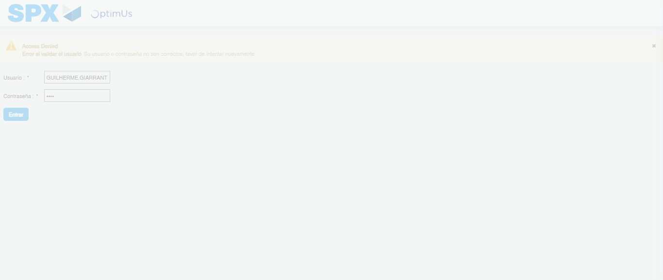Image file-name: QC_Testing-tc002_SPX_Dev5_Crear_Requisicion_Spot_Tipo_Cobro_Project-1784308751633

Step 2 - Select to UEN and Access to Spot Buy Requisitions : UEN Correctly selected and Correct access
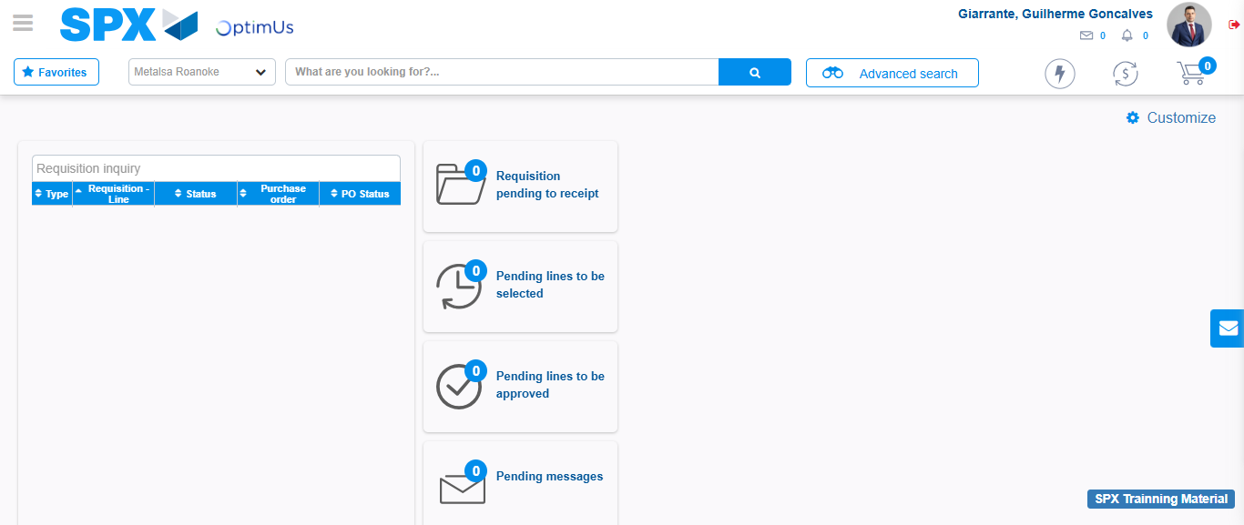Image file-name: QC_Testing-tc002_SPX_Dev5_Crear_Requisicion_Spot_Tipo_Cobro_Project-1784308813764

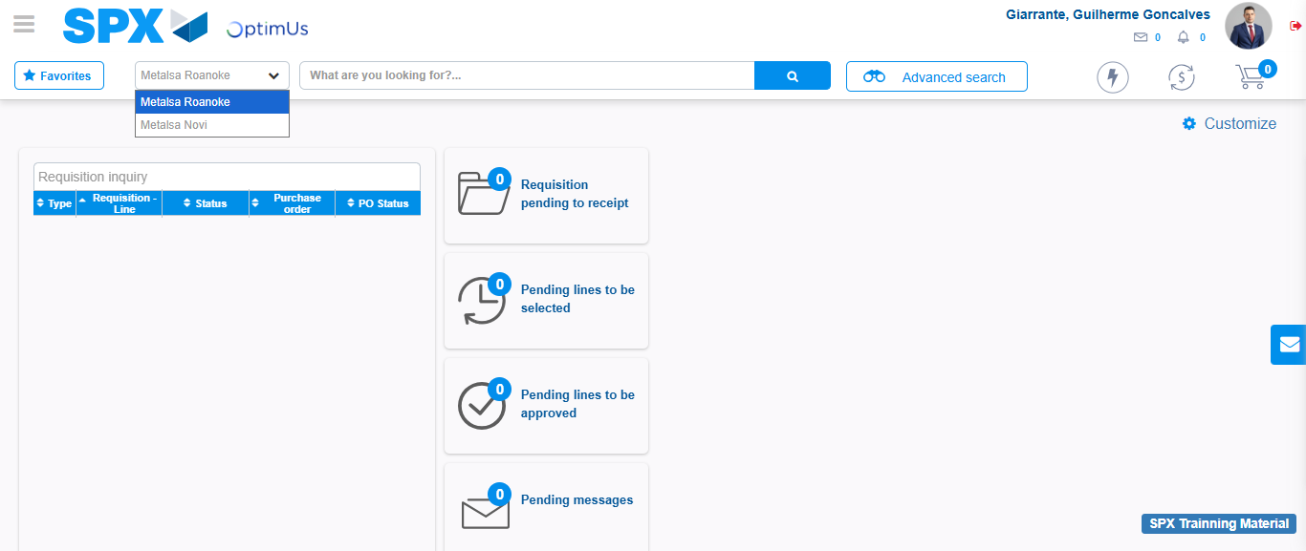Image file-name: QC_Testing-tc002_SPX_Dev5_Crear_Requisicion_Spot_Tipo_Cobro_Project-1784308816309

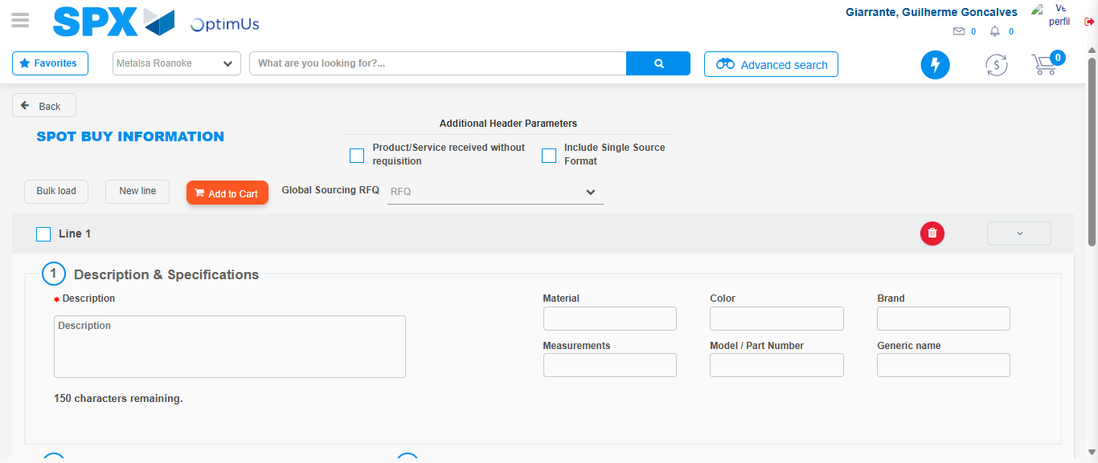Image file-name: QC_Testing-tc002_SPX_Dev5_Crear_Requisicion_Spot_Tipo_Cobro_Project-1784308828102

Step 3 - Data Capture Spot Buy Requisition: Data captured correctly
Image file-name: QC_Testing-tc002_SPX_Dev5_Crear_Requisicion_Spot_Tipo_Cobro_Project-1784308828402

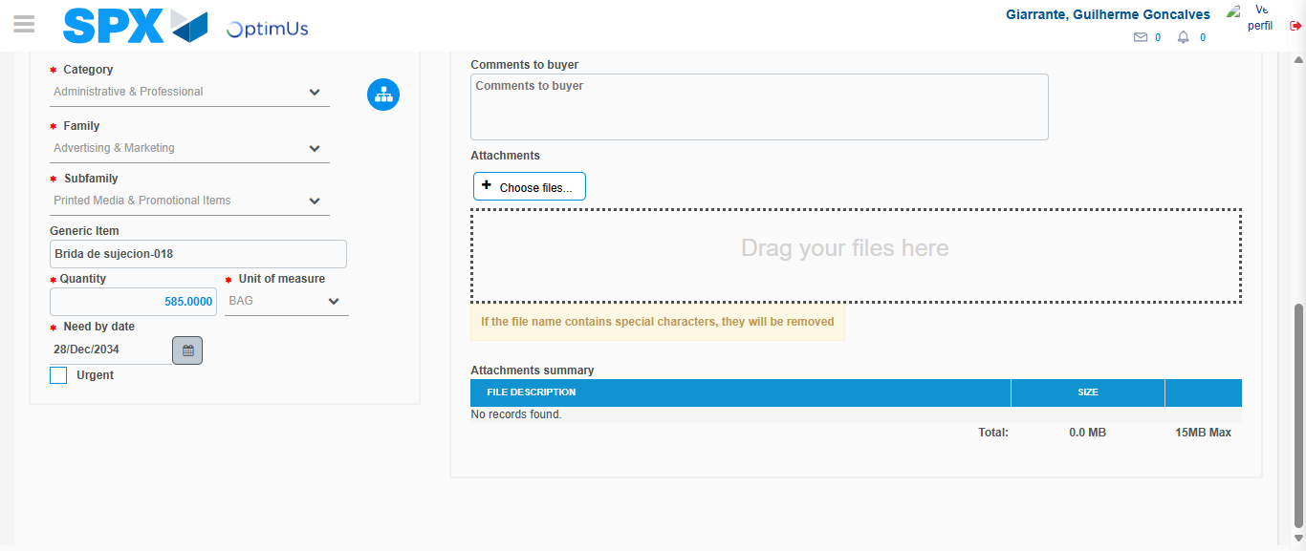Image file-name: QC_Testing-tc002_SPX_Dev5_Crear_Requisicion_Spot_Tipo_Cobro_Project-1784308840457

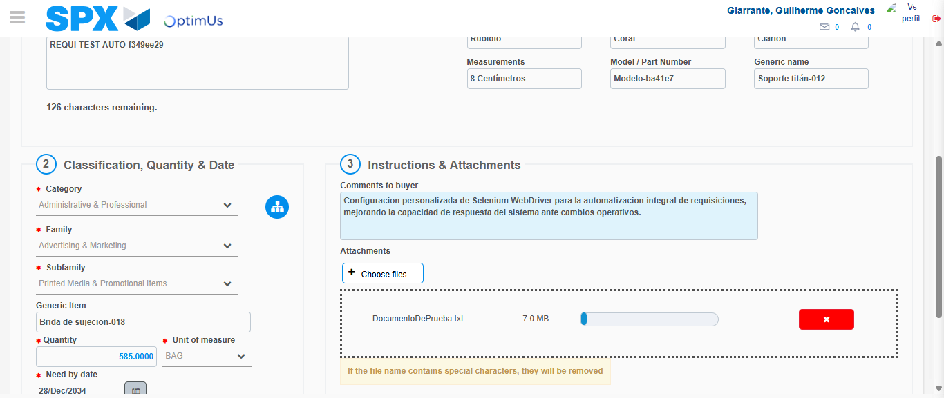Image file-name: QC_Testing-tc002_SPX_Dev5_Crear_Requisicion_Spot_Tipo_Cobro_Project-1784308841238

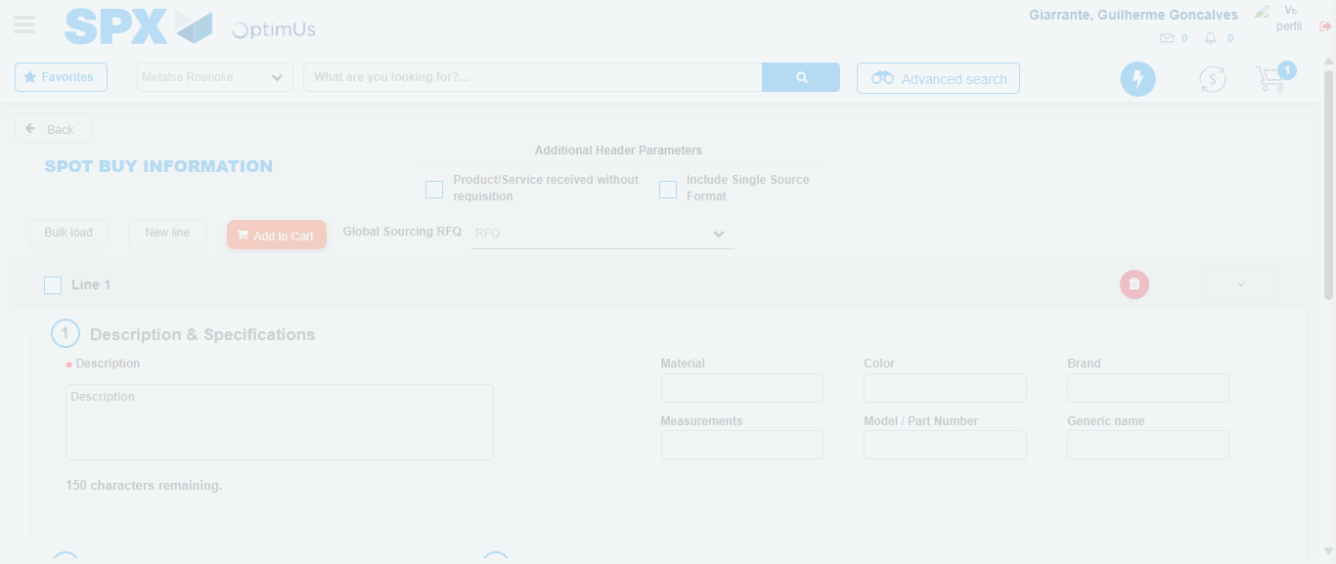Image file-name: QC_Testing-tc002_SPX_Dev5_Crear_Requisicion_Spot_Tipo_Cobro_Project-1784308842647

Step 7 - Return to Main Page SPX : Return to Main Page SPX
Image file-name: QC_Testing-tc002_SPX_Dev5_Crear_Requisicion_Spot_Tipo_Cobro_Project-1784308813764

Image file-name: QC_Testing-tc002_SPX_Dev5_Crear_Requisicion_Spot_Tipo_Cobro_Project-1784308816309

Image file-name: QC_Testing-tc002_SPX_Dev5_Crear_Requisicion_Spot_Tipo_Cobro_Project-1784308828102

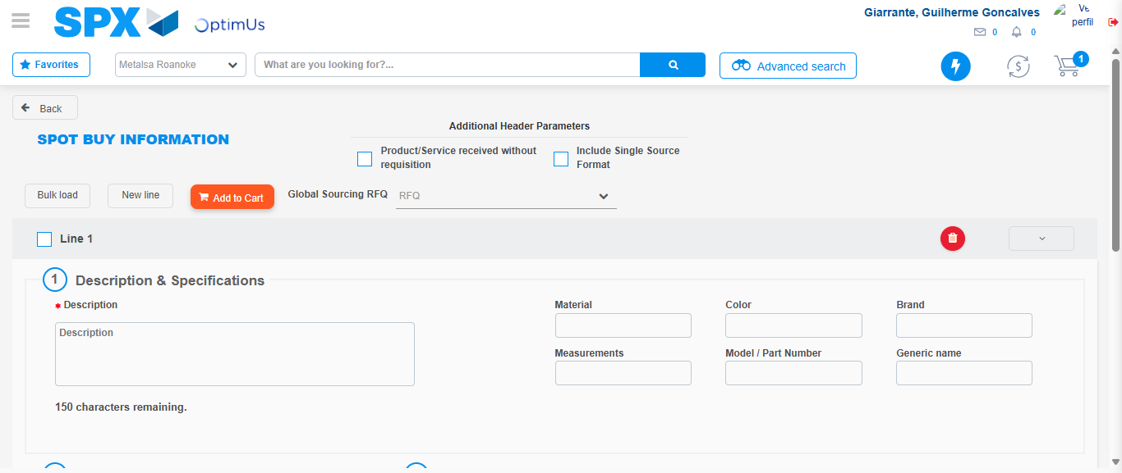Image file-name: QC_Testing-tc002_SPX_Dev5_Crear_Requisicion_Spot_Tipo_Cobro_Project-1784308844898

Image file-name: QC_Testing-tc002_SPX_Dev5_Crear_Requisicion_Spot_Tipo_Cobro_Project-1784308845071

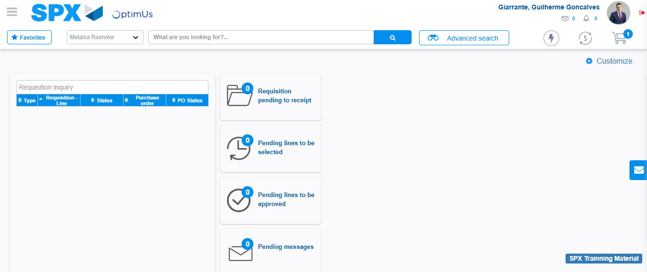Image file-name: QC_Testing-tc002_SPX_Dev5_Crear_Requisicion_Spot_Tipo_Cobro_Project-1784308866233

Step 8 - Log Out : Log Out SPX
Image file-name: QC_Testing-tc002_SPX_Dev5_Crear_Requisicion_Spot_Tipo_Cobro_Project-1784308866461

